AVIATRAX

SUDHIKSHA M K
Register No: 7176 22 31 055

DISSERTATION SUBMITTED IN PARTIAL FULFILMENT OF THE REQUIREMENTS FOR THE DEGREE OF
M.Sc. (Software Systems) OF ANNA UNIVERSITY



October 2025
DEPARTMENT OF COMPUTING COIMBATORE INSTITUTE OF TECHNOLOGY
(Autonomous Institution affiliated to Anna University) COIMBATORE – 641014

COIMBATORE INSTITUTE OF TECHNOLOGY

(Autonomous Institution affiliated to Anna University)
COIMBATORE 641014

(Bonafide Certificate)

Project Work - I Seventh Semester

AVIATRAX

Bonafide record of work done by

SUDHIKSHA M K

(Register No: 7176 22 31 055)

Submitted in partial fulfilment of the requirements for the degree of M.Sc. (Software Systems) of Anna University

October 2025

Faculty Guide Head of the Department

Submitted for the viva-voce held on

Internal Examiner External Examiner

CONTENTS

CHAPTER | PAGE NO
ACKNOWLEDGEMENT | i
SYNOPSIS | ii
PREFACE | iii
I INTRODUCTION | 1
1.1 ORGANIZATION PROFILE | 1
1.2 PROBLEM DEFINITION | 1
1.3 SYSTEM ENVIRONMENT | 3
II SYSTEM ANALYSIS | 5
2.1 SYSTEM DESCRIPTION | 5
2.2 USE CASE MODEL | 6
2.3 SOFTWARE REQUIREMENTS SPECIFICATION | 11
2.4 TEST PLAN | 17
III SYSTEM DESIGN | 21
3.1 ARCHITECTURAL DESIGN | 21
3.2 STRUCTURAL DESIGN | 23
3.3 BEHAVIOURAL DESIGN | 29
3.4 TABLE DESIGN | 33
3.5 USER INTERFACE DESIGN | 36
3.6 DEPLOYMENT DESIGN | 41
3.7 NAVIGATION DESIGN | 42
IV SYSTEM TESTING | 44
4.1 TEST CASES AND TEST REPORTS | 44
V SYSTEM IMPLEMENTATION | 47
5.1 INSTALLATION PROCEDURE | 47
VI CONCLUSION | 49
BIBLIOGRAPHY | 50

ACKNOWLEDGEMENT

The Success is achieved through mentorship, guidance, and the support of many people. I take this opportunity to express my sincere gratitude to all those who have provided invaluable encouragement and direction throughout this project. Their contributions have been instrumental in its successful completion.

I respect and thank Dr. A. RAJESWARI, Principal, Coimbatore Institute of Technology, for providing me with the opportunity to undertake this full-time industry project.

I thank Dr. K. SAKTHI MALA, Dean of Computing, Professor and Head of Department of Computing (Software Systems) Coimbatore Institute of Technology for her motivation, constant support, and guidance throughout the project work, inspiring me to achieve higher.

I am indebted to my internal guide, Ms. V. SHANTHI, Assistant Professor (Sr.Grade), Department of Computing-Software Systems, Coimbatore Institute of Technology, Coimbatore, for her constant support and guidance throughout the project.

Additionally, I am sincerely thankful to my external guide, Mr. D. MOHAN, Manager, VISTA Engg Solutions Pvt. Ltd., Coimbatore for his invaluable assistance and insights across various aspects of this project.

Finally, I would like to acknowledge the faculty and staff of Department of Computing, Coimbatore Institute of Technology for their encouragement and support throughout the project.

SYNOPSIS

Aviatrax is a workforce and quality assurance (QA) management system developed to overcome the inefficiencies of manual methods such as spreadsheets, paper forms, and scattered email communication. These outdated practices often cause delays, errors, and compliance gaps due to the absence of version control and real-time visibility. Aviatrax addresses these issues by offering a unified platform that centralizes staff management and automates QA workflows, providing role- based access, interactive dashboards, and structured processes for document handling, inspections, and reporting.

The project began with the staff and task management module, which streamlined employee onboarding, role assignment, and task allocation through a secure role-based access model. Managers gained real-time visibility into task progress via dashboards, while employees could update their status seamlessly. This approach was chosen to minimize human error, improve accountability, and ensure efficient coordination between teams.

The QA automation module was then developed to digitize and control document and inspection workflows. Plan documents could be uploaded with alphabet-based version tracking, reviewed by QA teams, and approved with digital signatures. Inspection requisitions were automated with internal and external categorization, while structured review comments and justifications ensured traceable communication, reducing turnaround times and improving transparency.

To enhance monitoring and compliance, real-time dashboards, notification systems, and audit logs were implemented. Customized dashboards provided role-specific insights, notifications ensured timely updates on approvals and deadlines, and audit trails recorded all key actions such as uploads, inspections, and approvals. These features improved collaboration across departments and created a reliable system of record for quality processes.

Aviatrax is built with Vue.js for a responsive front end, Flask for a lightweight and flexible backend, and PostgreSQL for secure data storage. The system is hosted on the organization’s internal servers, ensuring compliance with IT policies and safeguarding sensitive data. This technology stack was deliberately chosen for its scalability, maintainability, and compatibility, making Aviatrax a robust and future-ready solution.

PREFACE

CHAPTER I – INTRODUCTION
This chapter provides an overview of the organization where the project was completed. It introduces the Aviatrax project, describing the system that was developed along with the environment in which it was built and deployed.

CHAPTER II - SYSTEM ANALYSIS
This chapter explores the problem in detail through system analysis, defining requirements, specifications, and the proposed system's features. It also describes the functional and non-functional requirements of the system.

CHAPTER III - SYSTEM DESIGN
This chapter explains the design of the system that developed with related diagrams which outlines the different phases of the system development and elucidates the user interface flow.

CHAPTER IV - SYSTEM TESTING
This chapter details the testing phase, showcasing various test cases along with their respective outcomes.

CHAPTER V - SYSTEM IMPLEMENTATION
This chapter describes the implementation phase, listing the necessary pre-installed software and providing a walkthrough of key validations performed to ensure system functionality.

CHAPTER VI – CONCLUSION
This chapter summarizes the unique features of the Aviatrax project and offers suggestions for future enhancements.

CHAPTER I

INTRODUCTION

Aviatrax is an integrated workforce and quality assurance (QA) platform developed to modernize staff coordination and streamline quality processes within organizations. It eliminates the inefficiencies of traditional manual methods by digitizing task allocation, document reviews, and inspection tracking. The system enables role-based collaboration, automates version-controlled document handling, and provides real-time dashboards for monitoring progress. With its structured workflows and secure internal hosting, Aviatrax enhances accountability, reduces delays, and ensures transparent, compliant operations across teams.

ORGANIZATION PROFILE

Vista Engineering Solutions (Vista ES) is a global technology and engineering firm specializing in AI/ML, cloud computing, embedded systems, and custom software development. It delivers intelligent and scalable enterprise-level platforms, mobile and web apps, and data- driven solutions designed to accelerate digital transformation and automate complex processes. With strong teams across the USA, Europe, and India, Vista ES serves sectors including mobility, aerospace, energy, and healthcare, and supports initiatives like Aviatrax with its software, ML, cloud, and embedded engineering expertise.

PROBLEM DEFINITION
The Aviatrax project addresses the challenges organizations face in managing workforce activities and quality assurance (QA) processes through manual methods. As teams grow, relying on spreadsheets, paper-based forms, and scattered communication leads to delays, miscommunication, and compliance gaps. Tracking document versions, inspection requisitions, and approvals manually increases the risk of errors, lack of accountability, and slower decision- making. Without an integrated system, maintaining transparency, traceability, and timely coordination between staff and QA teams becomes difficult. Aviatrax seeks to overcome these challenges by offering a centralized solution that digitizes staff management and automates QA workflows, ensuring accuracy, efficiency, and streamlined collaboration across the organization.

PROBLEM OBJECTIVE
The objective of Aviatrax is to improve workforce and quality assurance management by automating task allocation, document handling, and inspection workflows. The system aims to provide real-time visibility into staff activities and QA processes, reduce reliance on manual tracking methods, and streamline collaboration between teams through structured reviews and role-based access, ensuring greater transparency, accountability, and efficiency across the organization.

SCOPE
Aviatrax is designed to centralize staff management and quality assurance processes within an organization. It enables employee onboarding, role-based task allocation, and real-time tracking of task progress and performance. The system digitizes QA workflows by supporting version- controlled document uploads, structured reviews with comments and justifications, and automated management of inspection requisitions. It also provides real-time dashboards for employees, managers, and QA teams to monitor tasks, approvals, and inspection statuses. The scope includes integrated notifications and audit trails, ensuring timely updates, compliance, and transparent collaboration across all teams.

USERS
The system is built for five main user groups:
      - Aviatrax System Administrator: Manages overall system operations, user accounts, and security compliance.
      - HR Team: Handles employee onboarding, role assignment, and staff records within the staff management module.
      - Managers: Allocate tasks to employees, track progress, and monitor performance metrics.
      - Team Leads: Oversee day-to-day task execution, track team activities, and provide feedback on task status.
      - QA Head/Reviewers: Review documents, manage inspections, provide structured approvals, and ensure compliance with QA standards.
      - Employees/Design Team Members: Execute assigned tasks, upload documents, submit requisitions, and respond to QA feedback.

LIMITATIONS
Aviatrax relies on predefined role structures, which can limit flexibility in organizations with frequently changing team setups or evolving hierarchies. While document handling, version control, and inspection tracking are automated, exceptional or complex workflows may still require occasional manual intervention to maintain accuracy and compliance. The system also depends on timely and consistent user updates for tasks, reviews, and approvals, and any delays or incomplete inputs can impact the accuracy of dashboards, reports, and overall process tracking.

SYSTEM ENVIRONMENT
The system environment for the Aviatrax project includes the hardware and software specifications necessary for its development, testing, and deployment. This section highlights the key components, tools, and technologies used across the project lifecycle, ensuring secure access, reliable performance, and smooth operation of both the staff management and QA automation modules.

HARDWARE SPECIFICATION
Table 1.3.1 shows the specifications of the hardware, including the hardware additives used when constructing the application.

Table 1.3.1 Hardware Specifications

Processor | Intel Core i5 or higher
System Type | 64-bit Operating System
RAM | 16.0 GB
Hard Disk Drive | 512 GB SSD
Server Hosting | Internal on-premise server

These specifications ensure smooth operation of the Aviatrax platform, supporting its staff management and QA automation modules with reliable performance and secure internal hosting.

SOFTWARE SPECIFICATION
Table 1.3.2 presents the specifications of the software tools and frameworks used to develop and deploy the Aviatrax application, detailing each component’s purpose and function.

Table 1.3.2 Software Specifications

Operating System | Windows 11
Programming Languages | Python, JavaScript, CSS
Frameworks | Flask, Vue.js
Database | PostgreSQL
IDE | Visual Studio code

DEVELOPMENT ENVIRONMENT

- Development is carried out using Visual Studio Code for efficient code management, debugging, and version control.
- The front-end is developed using Vue.js, supported by CSS and JavaScript for responsive styling and interactive user interfaces.
- The back-end is implemented using the Flask framework, ensuring a lightweight, scalable, and maintainable architecture.
- The database layer is built with PostgreSQL, providing secure, reliable, and structured data storage for staff management and QA workflows.

DEPLOYMENT ENVIRONMENT

- Deployed on internal on-premise servers to ensure IT policy compliance and data security.
- Supports scalability and modular upgrades for growing workloads.
- Uses CI/CD pipelines for automated testing, quality checks, and smooth deployments.
- Accessible via modern web browsers with secure, role-based login.

CHAPTER II SYSTEM ANALYSIS
System analysis is a process of studying the system in order to identify the goals,
purpose of the system and better understanding of the system’s requirements. This chapter gives a brief discussion about the detailed study of the proposed system and the different functionalities involved in the system.

SYSTEM DESCRIPTION
This section provides an analysis of the existing system's challenges and introduces the proposed Aviatrax system, outlining its features and benefits over the current setup.

EXISTING SYSYEM
The existing workforce and quality assurance (QA) processes are predominantly manual, relying on spreadsheets, paper-based forms, and unstructured communication methods. These practices result in inefficiencies in task allocation, document version control, and inspection tracking. Furthermore, the absence of structured workflows and real-time dashboards leads to delays, increased error rates, compliance challenges, and limited visibility into staff activities and overall QA performance.

PROPOSED SYSYEM
The proposed Aviatrax system streamlines staff management and quality assurance by centralizing task allocation, document handling, memos, reports, and inspection workflows in a single platform. Employees can be onboarded, assigned roles, and tracked in real time, while QA processes are automated through version-controlled document uploads, structured reviews, and digital approvals. Memos and reports can be filled, reviewed, and approved or disapproved as required, ensuring full traceability. Interactive dashboards display task statuses, memos, reports, and inspection results, and integrated notifications keep users updated on approvals, deadlines, and delays. Built on a scalable modular architecture and hosted on secure internal servers, Aviatrax ensures reliable performance, data security, and efficient collaboration across teams.

FEATURES OF THE PROPOSED SYSYEM

      - Centralized Staff and QA Management: The system consolidates staff management, task allocation, document handling, memos, reports, and inspection workflows within a single secure platform, eliminating the need for fragmented manual processes.
      - Automated Task and QA Workflows: Aviatrax supports real-time task assignment, document version control, and structured reviews with digital approvals, thereby reducing manual effort and enhancing process traceability.
      - Memo and Report Handling: Memos and inspection reports can be filled, reviewed, and approved or disapproved within the platform, ensuring transparent communication and clear decision tracking.
      - Real-Time Interactive Dashboards: Role-based dashboards provide instant visibility of task statuses, memos, reports, and inspection progress, with filtering and search options for quick access to historical records and key performance metrics.
      - Integrated Notifications: Built-in alerts notify users of approvals, deadlines, task updates, and pending actions, ensuring timely responses and uninterrupted workflow management.
      - Secure Internal Hosting: The system is deployed on internal servers and protected by role-based access controls to safeguard sensitive data and maintain organizational compliance.
      - Audit Trail and Activity Logs: All critical actions, including uploads, approvals, and status changes, are automatically logged with timestamps to support complete traceability for reviews and audits.
      - Scalable Modular Architecture: Aviatrax is designed with a modular architecture that facilitates scalability, future enhancements, and seamless integration with other enterprise applications.

USE CASE MODEL
A use case diagram is a visual tool used in system analysis to depict the interactions between users and a system. It provides an overview of the main functionalities, or "use cases," that a system offers and shows how various user roles interact with these functionalities. By clearly mapping out who can perform which actions, use case diagrams help to clarify system requirements, ensuring that the development team and stakeholders have a shared understanding of user needs and system capabilitie

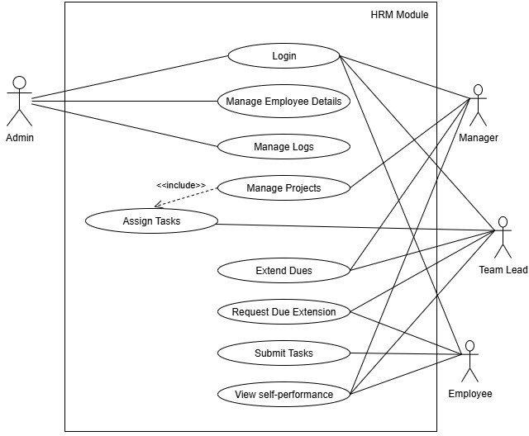

Figure 2.1 Use Case Model for HRM Module
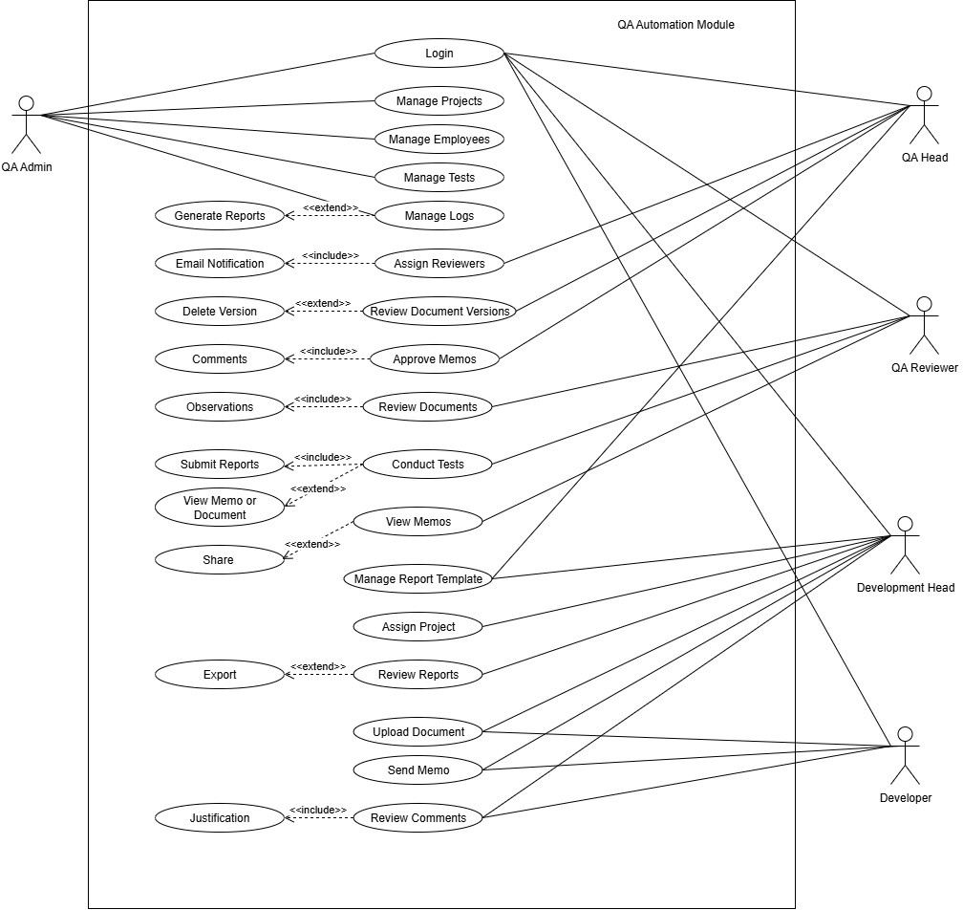
Figure 2.2 Use Case Model for QA Automation Module

    - USE CASE DESCRIPTION

- LOGIN

Goal | To allow users to securely access the Aviatrax system based on their roles.
Actor(s) | System Administrator, HR Team, Managers, Team Leads, Employees, QA Admin, QA Head, QA Reviewer, Development Head, Developer
Description | Users authenticate through the login module to access their respective HRM or QA functionalities.
Precondition | The user must have valid login credentials
Postcondition | User is logged in and directed to their role-specific dashboard.
Main flow of events | - User enters login credentials.  - System validates credentials.  - User is granted access and redirected to the dashboard.
Exceptions | Invalid credentials or inactive accounts deny access and prompt an error message.

- MANAGE EMPLOYEES

Goal | To add, edit, or remove employee records within the HRM and QA modules.
Actor(s) | System Administrator, HR Team, QA Admin
Description | Authorized users maintain employee information to support staff management and QA assignments.
Precondition | User is logged in with management privileges.
Postcondition | Employee details are updated and stored in the system database.
Main flow of events | - User selects Add/Edit/Delete option.  - Inputs or updates employee details.  - Saves changes to the system.
Exceptions | Invalid or incomplete data prompts an error message until corrected.

- ASSIGN TASKS

Goal | To allocate tasks or projects to employees, team leads, or developers.
Actor(s) | Managers, Team Leads, QA Head
Description | Authorized users assign work items with deadlines and instructions to relevant staff.
Precondition | Assigning user is logged in with appropriate permissions.
Postcondition | Assigned tasks appear in the assignee’s dashboard with all  details.
Main flow of events | - Manager/Lead selects a project or task.  - Enters assignment details and deadlines.  - Confirms assignment.  - System notifies the assigned user.
Exceptions | Conflicts or unavailable resources trigger a prompt to select another assignee.

- MANAGE PROJECTS

Goal | To create, update, and track project details across HRM and QA modules.
Actor(s) | System Administrator, Managers, QA Head, Development Head
Description | Authorized users define project scope, milestones, and deadlines for both staff and QA activities.
Precondition | User is logged in with project management privileges.
Postcondition | Project details are stored and accessible to assigned teams.
Main flow of events | - User creates or edits a project entry.  - Adds team members, tasks, and schedules.  - Saves updates to the system.
Exceptions | Missing mandatory fields prompt corrective input.

- REVIEW DOCUMENTS & MEMOS

Goal | To enable QA personnel to review, comment, and approve or disapprove documents and memos.
Actor(s) | QA Reviewer, QA Head, Development Head
Description | QA personnel ensure all submissions meet quality standards before approval.
Precondition | Relevant documents or memos are uploaded and awaiting review.
Postcondition | Approved or disapproved status is recorded and notifications are sent.
Main flow of events | - Reviewer are assigned with document or memo.  - Provides comments or observations.  - Approves or disapproves the submission.  - System records decision and sends notifications.
Exceptions | Network or file format issues delay review; user is prompted to retry.

- GENERATE REPORTS

Goal | To compile inspection results, test outcomes, memo statuses, and performance metrics into structured reports for audits and project tracking.
Actor(s) | QA Admin, QA Head, Managers
Description | Authorized users generate detailed or summary reports containing test types, QA inputs, system-evaluated results (Passed, Failed, or Passed with Observations), task statuses, and memo/override decisions.
Precondition | Relevant tasks, memos, or inspection data exist in the system.
Postcondition | Reports with final test outcomes are generated and ready for export or sharing in PDF or DOCX format.
Main flow of events | - User selects report type and filters.  - System retrieves and compiles inspection, test, and memo data.  - Report is generated and displayed for review or download.
Exceptions | Missing data or server errors trigger a retry or an error message.

  - SOFTWARE REQUIREMENTS SPECIFICATION
A software requirements specification (SRS) is a comprehensive document that outlines the necessary requirements for a software product. It includes both functional and non-functional requirements and often involves the use of use cases to describe user interactions with the software.

    - FUNCTIONAL REQUIREMENTS

User Authentication (Login)
Requirement: Secure login for all user roles to ensure authorized access.
  - Description: Users authenticate with valid credentials to access the functionalities according to their assigned roles.
  - Inputs: Username and password.

Processing Steps:
    - System validates credentials against stored records.
    - User role is identified and mapped to appropriate access permissions.
  - Output: User is logged in and redirected to their role-specific dashboard with authorized features.

Role-Based Access Control (RBAC)
Requirement: Enforce secure access based on user roles.
  - Description: Access to modules and functions is restricted based on predefined roles.
  - Inputs: User credentials and assigned roles.

Processing Steps:
    - User role is verified during login.
    - Access rights are applied dynamically to available functions.
  - Output: Secure access to authorized modules and features with activity logs.

Employee Onboarding
Requirement: Add and register new employees in the system.
  - Description: HR users create employee profiles with personal, professional, and role- related details.
  - Inputs: Employee name, contact details, designation, department, and joining date.

Processing Steps:
    - HR team enters employee details and assigns a unique employee ID.
    - System validates and stores the record.
  - Output: Successfully onboarded employee record with assigned credentials for system access.

Document Upload
Requirement: Upload and maintain plan documents with version control.
  - Description: Design or development teams upload project documents along with metadata for QA review and version tracking.
  - Inputs: Document file (PDF/DOCX), project details, version number, and submission date.

Processing Steps:
    - System validates file format and required metadata.
    - Version number is assigned and stored with timestamps.
    - Notifications are sent to QA reviewers for review.
  - Output: Version-controlled document available to authorized users with complete change history.

Document Review and Approval
Requirement: Review and approve or reject uploaded documents with structured feedback.
  - Description: QA reviewers evaluate submitted documents, provide observations, and record approvals or rejections.
  - Inputs: Document ID, reviewer comments, approval/rejection decision.

Processing Steps:
    - Reviewer accesses document and records comments.
    - System updates the document status and stores review history.
  - Output: Document marked as Approved, Rejected, or Revision Required with reviewer comments accessible to the design team.

Inspection Requisition Submission and Tracking
Requirement: Submit and track inspection requisitions after document approval.
  - Description: Design teams submit inspection requisitions for QA review and scheduling.
  - Inputs: Requisition form details including project information, part numbers, schedule, and attachments.

Processing Steps:
    - System validates completion of plan document approvals.
    - QA head reviews requisition details and provides approval or disapproval with comments.
  - Output: Updated inspection status (Pending/Approved/Rejected) with automatic notifications to stakeholders.

Memo Management and Overriding Requests
Requirement: Support memos for test requisitions and overriding requests to change the predefined test sequence.
  - Description: Design teams submit memos to request inspections. If a subsequent test must occur before the current one is cleared, an overriding request is raised for QA Head approval.
  - Inputs: Test requisition ID, project details, requested test order, justification.

Processing Steps:
    - Design team submits override request.
    - QA Head reviews and approves or disapproves.
    - System updates test sequence and issues notifications.
  - Output: Memo status recorded as Approved or Disapproved, with approved overrides reflected in the inspection schedule.

Task Assignment and Inspection Management
Requirement: Assign inspection tasks and track inspection progress.
  - Description: QA heads assign inspection tasks to QA team members and monitor progress until completion.
  - Inputs: Task details, assigned team member, inspection schedule, and progress updates.

Processing Steps:
    - QA head assigns tasks to designated reviewers or inspectors.
    - Team members update progress and upload inspection results.
  - Output: Updated inspection dashboard with real-time task status and completed inspection reports.

Test Type Configuration and Automated Report Evaluation
Requirement: Define test types and automatically determine final test outcomes.
  - Description: Administrators configure all required test types and expected input fields. QA teams enter test results, and system logic evaluates the data to conclude whether a test is Passed, Failed, or Passed with Observations.
  - Inputs: Test type details, QA inputs for each field, predefined evaluation rules.

Processing Steps:
    - Admin sets up test types and corresponding parameters.
    - QA team submits test data.
    - System applies logic to evaluate results and determine the final outcome.
  - Output: Automatically generated final status stored in the test report.

Comment-Based Communication
Requirement: Enable structured feedback exchange between QA teams and design teams.
  - Description: Users provide clarifications, justifications, and observations linked to specific documents or tasks.
  - Inputs: Comment text, associated task or document ID, and comment classification.

Processing Steps:
    - Comments are stored with metadata including user ID and timestamps.
    - Notifications are sent to relevant stakeholders.
  - Output: Real-time threaded communication visible within the related task or document.

Report Generation and Archival
Requirement: Generate and archive final inspection reports for future reference.
  - Description: QA teams prepare and store final inspection reports, which can be retrieved for audits or analysis.
  - Inputs: Final inspection details and supporting documents.

Processing Steps:
    - System validates completeness of the inspection record.
    - Reports are compiled and stored with searchable tags.
  - Output: Downloadable and exportable inspection reports in PDF or DOCX format.

Audit Trail and Activity Logs
Requirement: Maintain complete logs of all user actions for accountability.
  - Description: Every critical action such as document uploads, reviews, approvals, and task updates is recorded for audit purposes.
  - Inputs: Automatic capture of user actions and timestamps.

Processing Steps:
    - System records and stores all activities in secure logs.
    - Logs remain queryable for administrative review.
  - Output: Detailed, exportable audit logs for internal and compliance audits.

Notifications and Alerts
Requirement: Notify employees about tasks, memos, and updates in real time.
  - Description: System generates automated notifications for new tasks, approvals, deadlines, or policy changes.
  - Inputs: Trigger events (task assignment, memo approval, role update).

Processing Steps:
    - System monitors trigger events.
    - Generates notifications and sends to the concerned user.
  - Output: Instant alerts displayed on dashboards and optionally sent via email.

News Updates
Requirement: Allow administrators to publish quick news updates visible to all users.
  - Description: Admin can add or repost short news updates that will hover in the live news panel of all user dashboards for 24 hours.
  - Inputs: News text, optional attachments or links.

Processing Steps:
    - Admin submits a news update.
    - System posts the update to the live news panel and sets a 24-hour expiration timer.
  - Output: News update displayed in the live panel for all users until expiry.

Customizable Login Page Background
Requirement: Enable customization of the login page background.
  - Description: Admin can update and manage the images used for the login page background to reflect branding or organizational themes.
  - Inputs: Image file(s) uploaded by the admin.

Processing Steps:
    - Admin uploads or selects a new image.
    - System validates and applies the image to the login page.
  - Output: Updated login page background visible to all users during authentication.

    - NON-FUNCTIONAL REQUIREMENTS

Performance
Aviatrax is designed to handle multiple concurrent users, large document uploads, and real- time dashboard updates with minimal latency. Core operations such as memo submissions, inspection tracking, and task allocation remain responsive under high workloads.

Scalability
The system’s modular architecture supports future growth in users, projects, and data volume. Additional modules or departments can be integrated without major changes to the existing infrastructure.

Reliability and Availability
The platform targets 99.9% uptime to ensure uninterrupted access to staff management and QA functions. Critical features such as task tracking, memo approvals, and inspection scheduling remain operational even during scheduled maintenance.

Security
All data transmissions are protected using HTTPS and TLS encryption. Role-based access control restricts operations according to user roles, while sensitive information, including credentials and documents, is securely stored and encrypted.

Usability
Aviatrax provides an intuitive, user-friendly interface with organized dashboards, search filters, and clear navigation. HR teams, QA personnel, managers, and employees can efficiently perform tasks with minimal training.

Integration
The system is built with flexible APIs to support future integration with HR tools, analytics platforms, and email services, enabling seamless communication and reporting.

Maintainabilit
A clean, modular codebase and comprehensive documentation enable easy maintenance, quick updates, and smooth implementation of new features without disrupting ongoing operations.

Data Accuracy
Automated validation checks and real-time synchronization ensure the accuracy of staff records, inspection schedules, and test results. Alerts notify administrators of discrepancies for immediate correction.

Auditability
All key activities—such as logins, document uploads, memos, approvals, and override decisions—are recorded with timestamps to maintain a complete audit trail for compliance and reviews.

    - ASSUMPTIONS AND DEPENDENCIES

ASSUMPTIONS
The Aviatrax system is developed with the understanding that all users, including HR staff, managers, QA personnel, and employees, possess basic computer proficiency and are provided with appropriate training to operate the application effectively. It is assumed that the internal servers and networks are properly configured and maintained to ensure stable and continuous operation. Furthermore, it is presumed that organizational roles, hierarchies, and workflow procedures are clearly defined, and that a reliable internal network connection is available to facilitate real-time updates, notifications, and data synchronization.

DEPENDECIES
The successful implementation of the Aviatrax system relies on several key dependencies. These include a stable internal server infrastructure capable of supporting real-time data processing, document management, and task tracking. The application depends on the proper configuration and maintenance of all hardware, networking equipment, and supporting software to ensure uninterrupted operations. Accurate definition of organizational roles, workflows, and inspection hierarchies is essential for effective task allocation, memo handling, and override approvals. In addition, timely updates from users and ongoing training and support are critical to maintain data accuracy, ensure smooth operations, and maximize overall system effectiveness.

TEST PLAN

The test plan for the Aviatrax system outlines a structured approach to ensure that both the QA Automation and Staff Management modules meet all functional and non-functional requirements. It covers unit, integration, system, and performance testing to validate reliability, scalability, and accurate task, memo, and inspection management. Usability testing is also included to confirm that HR staff, managers, QA personnel, and employees can efficiently navigate the interface for memo submissions, inspection tracking, and override approvals, ensuring smooth and error-free operations.

TEST SCOPE
The test scope for the Aviatrax system encompasses all critical functionalities of workforce management and quality assurance automation, including employee onboarding, role-based task allocation, document upload with version control, structured reviews, inspection requisitions, memo handling, and report generation. It further covers validation of real-time dashboards, notifications, and audit trails to ensure transparency, accountability, and timely updates across user roles. Testing also includes role-based authentication, data accuracy, and system reliability under concurrent usage to confirm secure access, consistent performance, and seamless collaboration within the platform.

TESTING FUNCTIONS

- User Authentication and Role-Based Access: Verification of secure login processes and enforcement of role-based access controls, ensuring that only authorized users can access functionalities specific to their roles.
- Employee Onboarding and Management: Testing the ability to add, edit, and remove employee records, validate proper role assignments, and confirm that onboarding details are accurately stored in the system.
- Task Allocation and Tracking: Validation of task assignment by managers and team leads, ensuring tasks appear in the assignee’s dashboard with correct details, deadlines, and real- time status updates.
- Document Upload and Version Control: Ensuring that documents are uploaded in supported formats, properly versioned, and accessible to QA reviewers with complete history tracking.
- Document Review and Approval: Testing structured review workflows where QA reviewers can provide comments, approve, or reject submissions, with accurate updates to status and notifications to stakeholders.
- Inspection Requisition and Memo Handling: Verification of inspection requisition submissions, approvals, and status tracking, along with memo submissions and override requests, ensuring decisions are recorded transparently.
- Report Generation and Archival: Testing the generation of structured reports on tasks, inspections, memos, and QA outcomes, validating export options (PDF/DOCX) and archival for future audits.

- Notifications and Alerts: Evaluating the system’s notification mechanisms for task updates, approvals, deadlines, and inspection outcomes, confirming timely and accurate communication across user groups.
- Dashboards and Data Visualization: Ensuring real-time dashboards accurately display staff activities, QA progress, inspection statuses, and memos, while remaining responsive under varying data volumes.
- Audit Trail and Activity Logs: Validation that all critical actions such as logins, uploads, approvals, and task updates are recorded with timestamps for accountability and compliance.

TESTING TECHNIQUES

- Functional Testing: This technique ensures that each of Aviatrax’s core functionalities, including employee onboarding, task management, document handling, reviews, inspections, memos, and reporting, operate as specified.
- Performance Testing: Given the high volume of data Aviatrax processes in real time, performance testing is critical. It Assesses system responsiveness, scalability, and stability under concurrent usage, document uploads, and real-time dashboard operations.
- Integration Testing: Integration testing verifies that Aviatrax’s components, particularly those that link HRM, QA workflows, document management, and reporting interact smoothly. This testing ensures correct data flow and functionality across interconnected modules.

TESTING TOOLS

- Vitest: This is applied for frontend testing of the Vue.js components in Aviatrax. It is used to verify user interfaces, form validations, and dashboard rendering. By confirming successful execution of component-level tests, Vitest ensures consistent functionality, reliable interactions, and a smooth user experience across the application.
- Pytest: This is utilized for backend testing of the Flask modules and APIs. It validates authentication, database transactions, and error handling to ensure stable and accurate data processing. Through automated test execution, Pytest helps maintain correctness, stability, and reliability in the system’s core backend services.

- Postman: This is essential for API testing, where it is used to validate endpoint functionality, response codes, headers, and payload accuracy. With Postman, testers can perform CRUD operations, automate test collections, and confirm seamless integration between the frontend and backend services, ensuring end-to-end reliability.
- JMeter: For performance testing, JMeter is employed to simulate concurrent users and high workloads. By executing stress and load tests, it enables the evaluation of Aviatrax’s response times, scalability, and stability under peak usage conditions, ensuring that the system meets performance expectations.

CHAPTER III SYSTEM DESIGN
System design is a set of procedures performed to convert the needs and requirements
of a business or organization into a design that can be implemented on the organization’s computer system. It identifies the software components, specifies relationships among the components, properties of both components and relations, defines program structure and provides a blueprint for implementation. The following chapter deals with the various design issues that guide the interface development of the application.

ARCHITECTURAL DESIGN
Architectural design is the process of defining a collection of structure of data, hardware and software components and their interfaces to establish the framework for the development of a computer-based system. It focuses on the decomposition of a system into different components and their interactions to satisfy functionality and performance requirements as well as non-functional requirements of the system. The software that is built for computer-based systems can exhibit one of these many architectural styles or patterns. An architectural pattern is a general, reusable solution to a commonly occurring problem in software architecture within a given context.

The Aviatrax project adopts a modular layered architecture hosted on secure internal servers. The system is organized into distinct layers for presentation, application logic, and data management, ensuring clear separation of responsibilities and ease of maintenance. The QA Automation and Staff Management modules operate as independent but integrated components, allowing updates or enhancements to one module without disrupting the other. Well-defined APIs and service interfaces support smooth communication between layers and modules, enabling features such as automated test evaluation, memo handling, and real-time notifications. This architecture enhances scalability, improves security within the internal network, and provides a stable framework for future expansions or the integration of additional quality assurance tools.

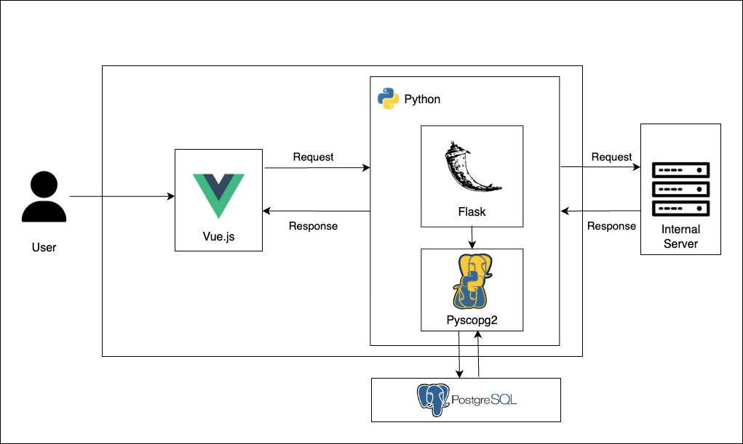

Figure 3.1 Architectural Design for Aviatrax

This system architecture follows a layered structure, illustrating the modular design employed in the Aviatrax project. Each layer represents a distinct responsibility, including the Vue.js front end, the Flask back end, and the PostgreSQL database, which work together to deliver an integrated staff management and QA automation solution. By separating the application into independent yet connected components, the architecture enhances modularity, scalability, and maintainability. The Flask backend manages core business logic, automated test evaluations, and memo processing, while PostgreSQL ensures secure and reliable data storage. The Vue.js interface enables smooth user interaction and real-time updates across HR, QA, and management roles. This layered approach promotes clear communication between components through REST APIs, allowing future integrations, background services, and feature expansions without disrupting existing operations, ensuring a robust and adaptable platform for inspection and staff management.

STRUCTURAL DESIGN
Structured design is a diagrammatic notation that is designed to help people understand the system. The basic goal of structured design is to improve quality and reduce the risk of system failure. It establishes concrete management specifications and documentation. It focuses on the solidity, pliability and maintainability of the system.

DATA FLOW DIAGRAM

A Data Flow Diagram (DFD) provides a graphical representation of the flow of data through an information system, illustrating how inputs are transformed into outputs. DFDs emphasize the movement of data between processes, data stores, and external entities, offering a functional view of the system.
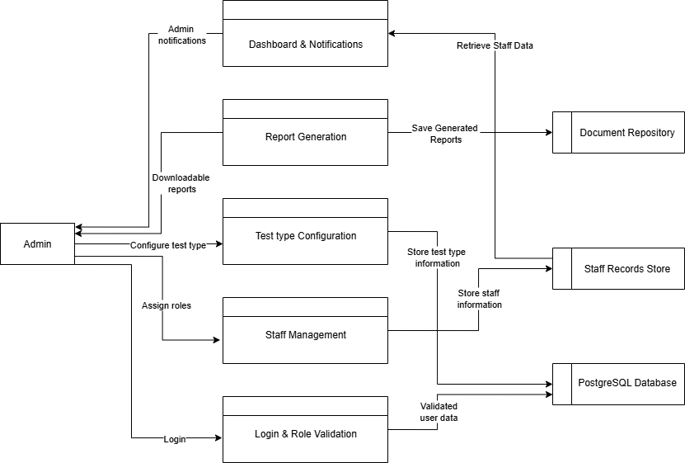

Figure 3.2 DFD of Aviatrax – 1

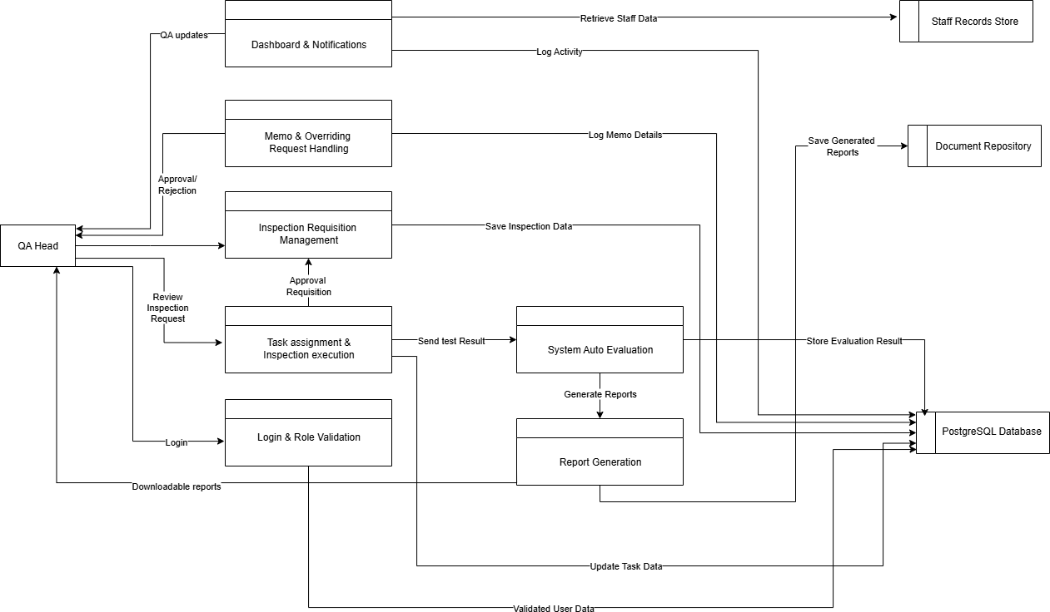

Figure 3.2 DFD of Aviatrax – 2

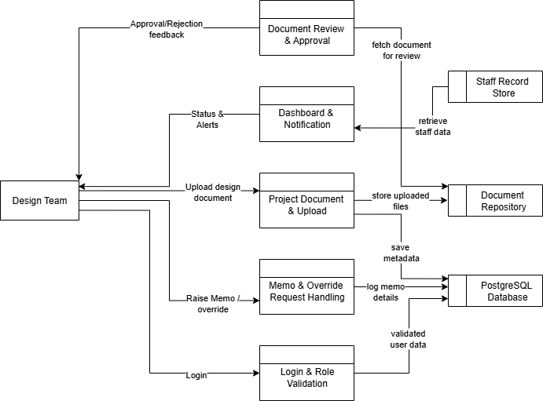
Figure 3.2 DFD of Aviatrax – 3

External Entities
        - Design/Development Team Entity
Represents the engineering or design teams responsible for uploading project documents, submitting inspection requisitions, and raising memos or override requests. These users initiate QA processes by providing design plans, part details, and testing requirements.

QA Admin Entity
The QA Admin oversees overall system operations, including managing projects, configuring test types, assigning tasks, and monitoring inspection progress. This role ensures that QA activities are executed according to organizational standards.

QA Head Entity
The QA Head reviews inspection requisitions, approves or rejects memos, and authorizes override requests for test sequence changes. This entity ensures that testing follows approved procedures while handling exceptions that require hierarchical approval.

Processes
  - Login and Role Validation
Handles secure user authentication and role verification. Users log in with credentials, and the system validates their access rights to ensure they can only perform actions permitted for their role (e.g., HR, QA Admin, QA Head, or Design Team).

Project Document Upload
Enables design teams to upload plan documents with version control. Metadata such as project details and version numbers are stored, and notifications are triggered for QA reviewers to begin evaluations.

Document Review and Approval
Allows QA reviewers to evaluate submitted documents, provide comments or observations, and approve or reject them. Approved documents progress to the inspection stage, while rejected documents return to the design team for revision.

Inspection Requisition Management
Facilitates the submission and tracking of inspection requests once documents are approved. QA Heads review requisitions, schedule inspections, and provide feedback on approval or disapproval.

Memo and Override Requests
Manages memos raised for test requisitions and override requests when a subsequent test must be conducted before the completion of a current test. QA Heads review and decide whether to allow the requested change in test sequence.

Test Type Configuration
Allows the QA Admin to define and maintain the various test types and their required parameters. These configurations guide QA teams when conducting inspections and recording results.

Task Assignment and Inspection Execution
QA Heads assign inspection tasks to QA team members, who then conduct tests based on the approved plans. Inspectors log results, observations, and any deviations encountered during the process.

System Auto-Evaluation
Applies predefined logic to the recorded test results to determine whether a test is passed, failed, or passed with observations. This automation ensures consistency in test status determination.

Report Generation
Compiles inspection results, test outcomes, memos, and activity logs into structured reports. Reports can be downloaded or shared for audits, project tracking, or management review.

Dashboard and Notifications
Provides a real-time interface for tracking document statuses, inspection progress, task assignments, and test results. The system also generates automated notifications to alert users of new tasks, approvals, deadlines, and updates.

Data Stores
  - PostgreSQL Database
Serves as the central repository for all system data, including user credentials, project documents, test results, memos, inspection schedules, and audit logs. It ensures secure, reliable storage and retrieval of data.

Document Repository
Stores all uploaded project documents and inspection reports with version control, enabling easy access to historical records and ensuring traceability during audits.

Staff Record Store
Maintains detailed information on all staff members, including personal details, assigned roles, project allocations, and performance records. It supports HR and QA teams in ensuring accurate role-based access and accountability within the system.

MODULE DIAGRAM

A module diagram is a design approach that subdivides a system into smaller parts called modules that can be independently created and then used in different systems. A modular system can be characterized by functional partitioning into discrete scalable, reusable modules; rigorous use of well-defined modular interfaces; and making use of industry standards for interfaces.
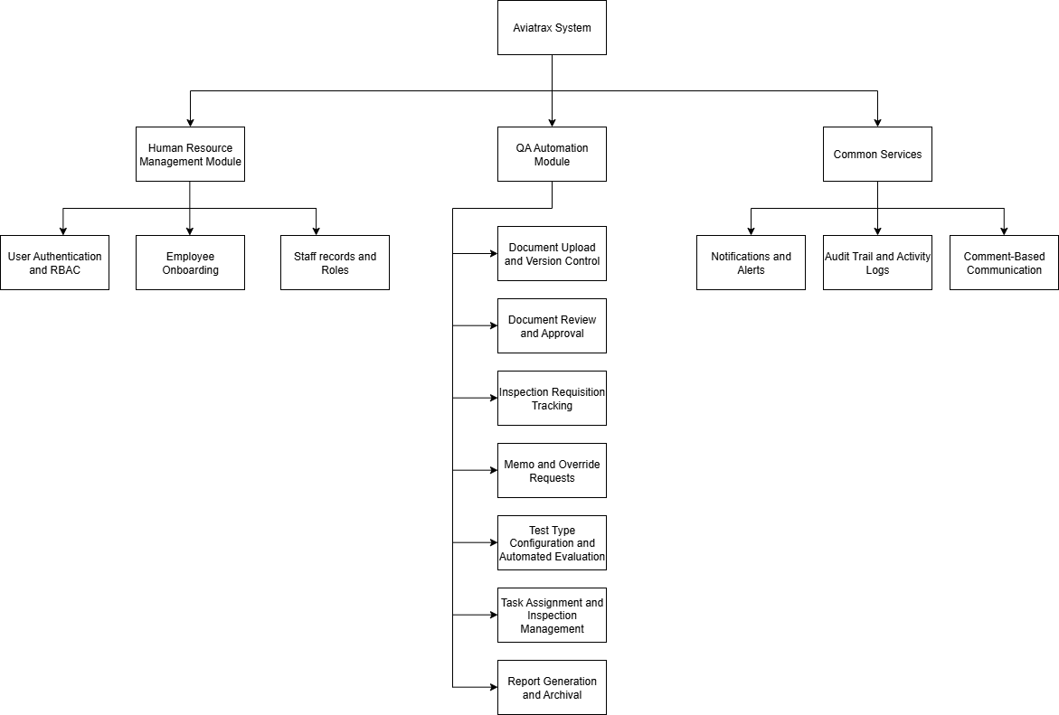

Figure 3.3 Module Design of Aviatrax

Human Resource Management Module
      - User Authentication and RBAC:
This module handles secure login for all user roles, including QA Admin, QA Head, HR staff, managers, team leads, and design team members. It validates user credentials and assigns appropriate access rights based on predefined roles. Successful login redirects users to their role-specific dashboard, ensuring authorized access to sensitive QA and staff management data.

Employee Onboarding:
Supports creation and registration of new employee profiles, including essential details, onboarding steps, and integration with role assignments.

Staff Records and Roles:
Maintains structured records of employees, their assigned roles, and permissions to ensure proper access control and accountability.

QA Automation Module
      - Document Upload and Version Control
Enables design teams to upload plans, drawings, and supporting files with built-in version tracking to maintain compliance and structured QA workflows.

Document Review and Approval
Allows QA reviewers to inspect uploaded documents, add observations, and mark them as Approved, Rejected, or Revision Required.

Inspection Requisition Tracking
Facilitates submission and monitoring of inspection requests after document approvals, including project details, part numbers, and schedules.

Memo and Override Requests
Provides tools for submitting memos for inspection requests or clarifications. Also manages override requests when a test needs to be rescheduled or reordered, with approval by QA Heads.

Test Type Configuration and Automated Evaluation
Lets QA Admins define and standardize test types. Supports automated recording and evaluation of test outcomes against expected criteria.

Task Assignment and Inspection Management
QA Heads can assign inspection tasks to staff, track progress, and record real-time results during inspections.

Report Generation and Archival
Compiles inspection data into structured PDF/DOCX reports. Finalized reports and memos are archived with searchable metadata for audits and regulatory compliance.

Common Services
      - Notifications and Alerts
Issues real-time alerts on pending tasks, approvals, inspection updates, and memo decisions via dashboards and email.

Audit Trail and Activity Logs
Maintains a detailed log of user actions including document uploads, approvals, inspections, and report generations for accountability and audits.

Comment-Based Communication
Provides threaded comment features on documents, memos, and inspection records to enhance collaboration and ensure contextual communication across teams.

BEHAVIOURAL DESIGN
Behavioural Design is a systematic approach that focuses on how a system responds to various inputs and events, aiming to enhance user experience and functionality. It emphasizes clear use cases and workflows, promoting a better understanding of user interactions. By concentrating on a system's dynamic aspects, behavioural design creates adaptable systems that evolve with user needs, supporting robust documentation and effective communication among stakeholders to minimize errors during implementation.

ACTIVITY DIAGRAM
Activity Diagram is a visual representation used to model the dynamic aspects of a system by illustrating the flow of control or data among various activities. It provides a clear view of the sequence of operations, decision points, and parallel processes within a specific workflow. By detailing the steps involved in a process, activity diagrams facilitate understanding, analysis, and communication among stakeholders, making them essential for identifying inefficiencies and optimizing system behaviour.
Figure 3.4 presents the activity diagram for the Aviatrax project, highlighting the end-to- end workflow across key roles such as System Administrators, HR staff, QA Heads, Managers, and Design Team members. The process starts with secure user login and role verification, directing each user to a role-specific dashboard. HR manages employee onboarding and role assignments, while the design team uploads documents and raises memos for inspections.

Approved documents lead to inspection requisitions, and when out-of-sequence tests are required, override requests are submitted for QA Head approval. Once a memo is accepted, the system automatically generates an empty report card in the report dashboard for further processing.
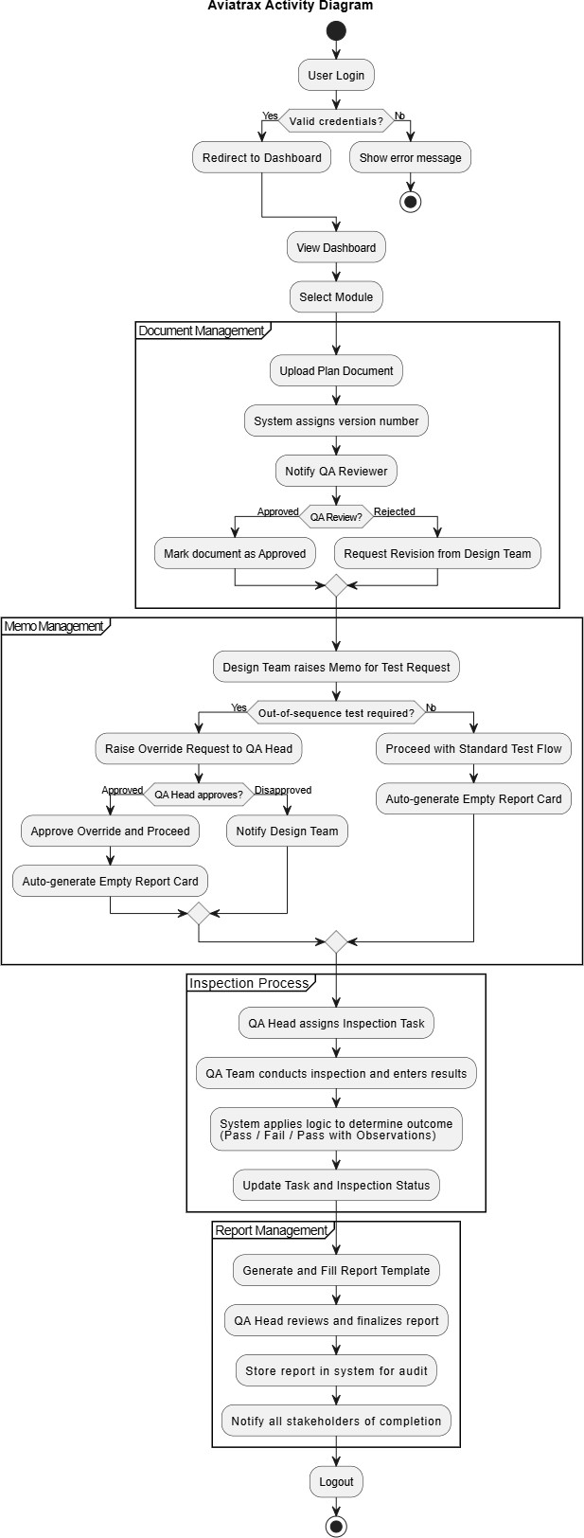
Following approval, the Design Head selects appropriate report templates based on the corresponding test types, and QA Heads assign inspection tasks to QA team members. Inspectors conduct tests, update progress, and submit results, while comments and notifications enable real- time communication among stakeholders. Completed inspections trigger automated report compilation using the chosen templates, and all activities are logged to maintain traceability. This activity diagram captures Aviatrax’s streamlined coordination of staff management, QA automation, and report generation.

Figure 3.4 Activity Diagram of Aviatrax

SEQUENCE DIAGRAM
A sequence diagram is a type of interaction diagram that models the sequence of messages exchanged between objects or components in a system over time. It illustrates how processes operate and the order in which interactions occur, highlighting the timing and flow of messages in a visually structured format. Sequence diagrams are essential for understanding dynamic behaviour within a system, as they detail the relationships and dependencies between different components, facilitating clear communication of system functionalities and requirements.
Figure 3.5 depicts the interactions between key actors and components within the Aviatrax project. It captures the flow of processes involving the System Administrator, HR staff, Design Team, QA Head, Inspectors, PostgreSQL database, and the internal server.
The diagram begins with secure user login and role verification, after which HR manages employee onboarding and the Design Team uploads documents for QA review. Approved documents lead to inspection requisitions and, when required, override requests for out-of- sequence testing. Upon memo acceptance, the system auto-generates a report card and notifies the Design Head, who selects appropriate report templates. QA Heads assign inspection tasks, inspectors conduct tests, and results are logged in PostgreSQL. Automated logic then finalizes report status (pass, fail, or pass with observations), and notifications are sent to relevant stakeholders, ensuring accurate QA tracking and efficient report generation

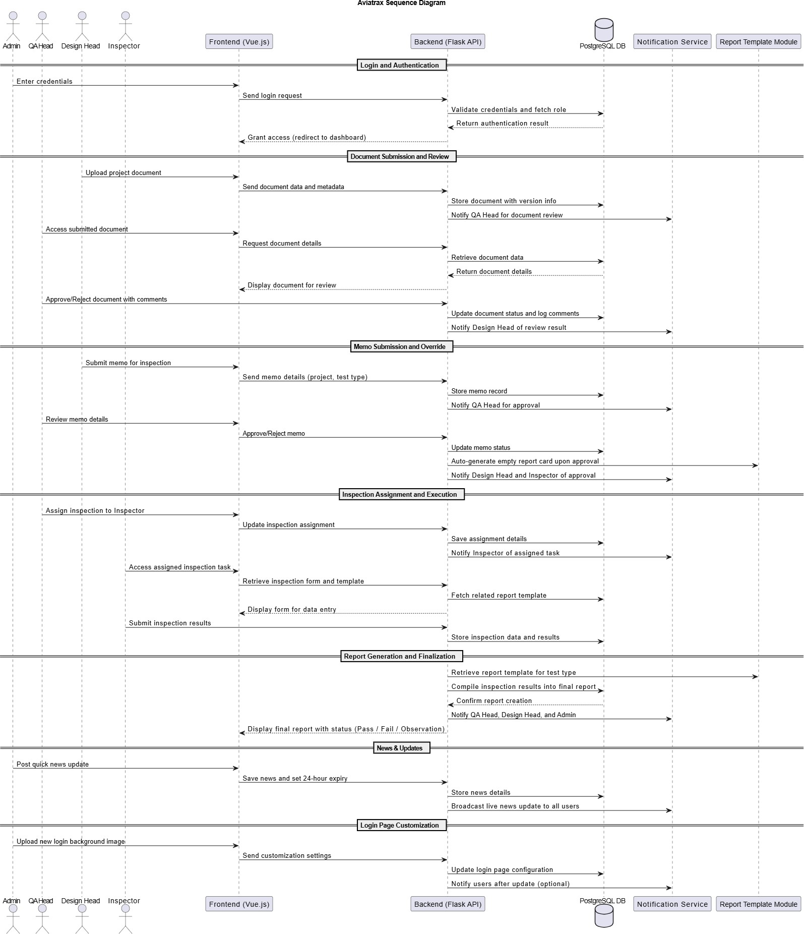

Figure 3.5 Sequence Diagram of Aviatrax

TABLE DESIGN
Database Design is a collection of processes that facilitate the designing, development, implementation and maintenance of enterprise data management systems. Sample table design is as follows.

ENTITY RELATIONSHIP DIAGRAM
An Entity-Relationship Diagram (ERD) is a visual representation of the entities within a system and their interrelationships. It serves as a foundational blueprint for database design and helps in understanding the data structure and organization. ERDs are composed of several key components:
- Entities: These are objects or things within the system that have a distinct existence. They can represent physical items, concepts, or events. In an ERD, entities are usually depicted as rectangles.
- Attributes: Attributes are the properties or characteristics of an entity.
- Relationships: Relationships illustrate how entities are connected to one another. They define the associations between entities, such as one-to-one, one-to-many, or many-to many. Relationships are typically represented by diamonds connecting related entities.
- Cardinality: This term refers to the number of instances of one entity that can be associated with instances of another entity. It provides crucial information about the nature of the relationship between entities.
- Primary Key (PK): A primary key is a unique identifier for an entity, ensuring that each instance can be distinguished from others. It is often underlined in the diagram.
- Foreign Key (FK): A foreign key is an attribute that creates a link between two entities, referencing the primary key of another entity. This helps establish relationships and maintain referential integrity.

Figure 3.6 ER Diagram of Aviatrax

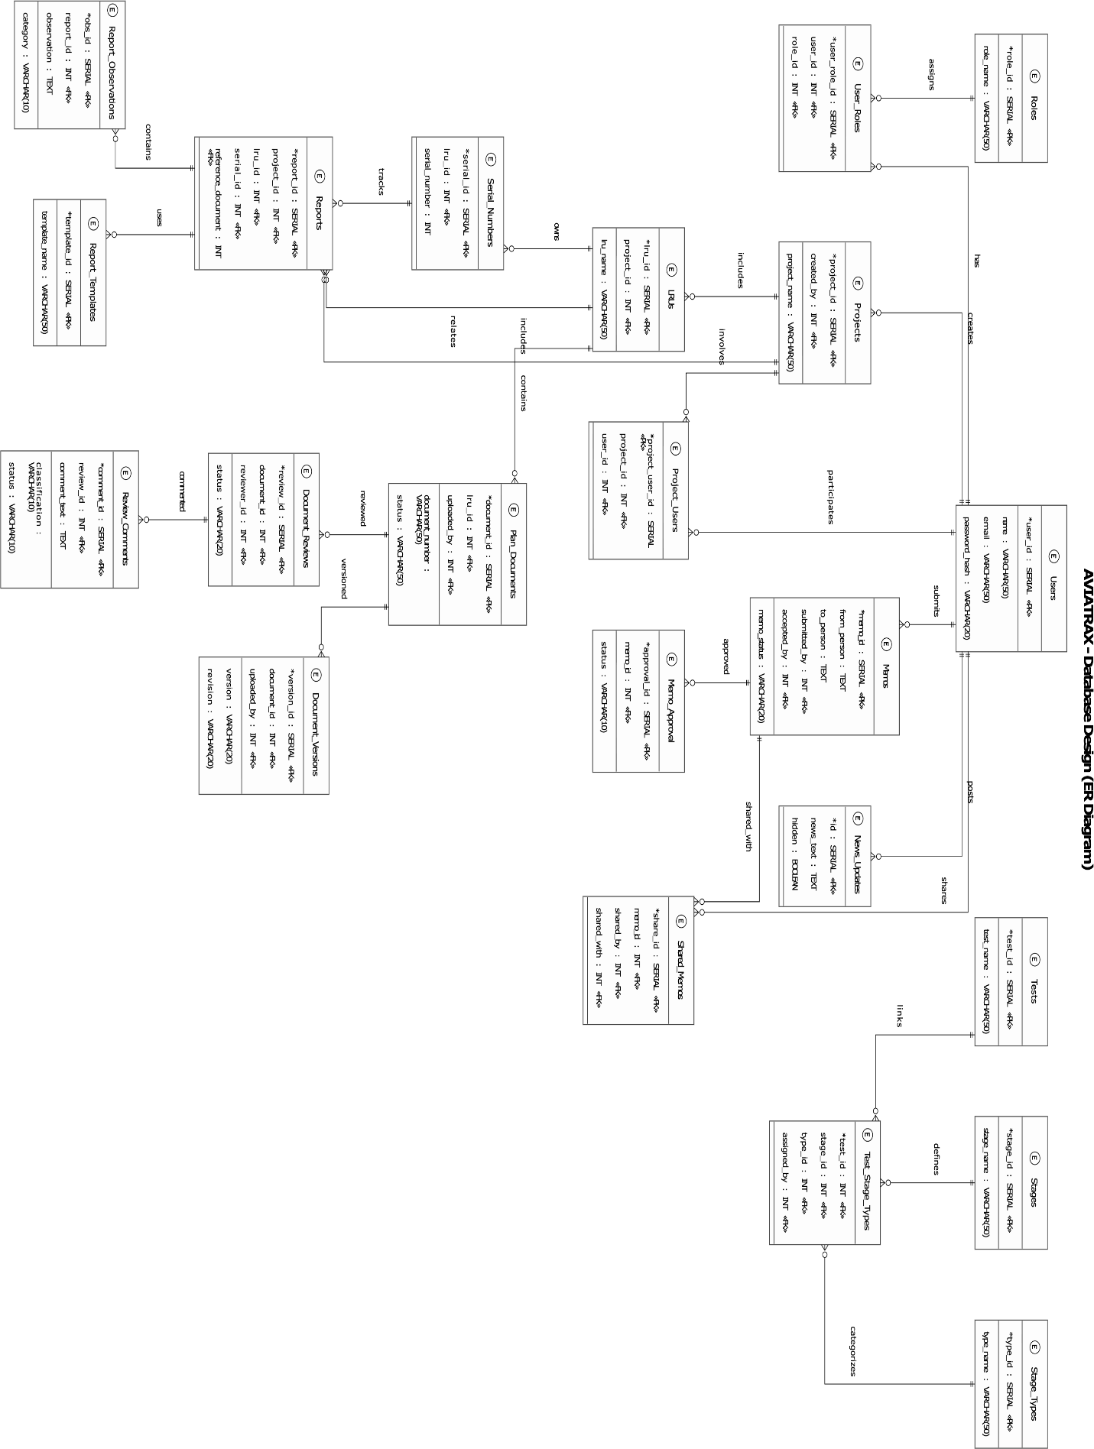

The ER diagram in Figure 3.6 represents the relationships between the primary entities that drive staff management and QA automation within the Aviatrax system.
The Users entity captures attributes such as user_id, name, email, and password_hash, representing different categories of system participants including System Administrators, HR staff, Design Team members, QA Heads, Managers, and Inspectors. User roles are managed through the Roles entity, with the User_Roles table linking users to their assigned permissions, ensuring proper access control across the system.
Projects are modeled through the Projects entity, storing attributes like project_id and project_name. Projects involve multiple participants via the Project_Users relationship and are further divided into logical units through LRUs . Each LRU may contain multiple Serial_Numbers, which can then be associated with inspections and reports.
The QA automation workflow is also shown in Figure 3.6. Here, the Plan_Documents entity represents uploaded design documents linked to projects and LRUs. Each document supports multiple Document_Versions and undergoes Document_Reviews, where reviewers can provide feedback stored in Review_Comments.
The Memos entity captures inspection requests or override needs, storing attributes such as memo_id, from_person, to_person, and memo_status. Each memo can go through Memo_Approval and may be shared using the Shared_Memos entity. Once a memo is approved, it triggers the creation of inspections managed through the Inspections entity, which records assigned staff, test type, schedule, and progress.
The testing process is standardized using the Tests, Stages, and Stage_Types entities. Their relationships are defined in Test_Stage_Types, ensuring each inspection follows consistent procedures.
When inspections are completed, reports are generated. The Reports entity captures report details and references predefined Report_Templates selected by the Design Head. Reports may also include Report_Observations linked to specific categories or outcomes.
Additionally, the News_Updates entity supports communication and visibility by allowing information and announcements to be shared across the system.
This structure ensures a clear integration of staff management with QA automation: users and roles govern access, projects organize work, documents and memos initiate quality processes, inspections enforce testing, and reports provide traceable outputs. Together, the ER model supports organized tracking, collaboration, and compliance within the Aviatrax system.

USER INTERFACE DESIGN

The User Interface Diagram for the Aviatrax system illustrates the application’s screen layouts and interactions through structured wireframes, highlighting how users navigate key modules such as staff management, document control, QA automation, and report generation. It provides a clear view of the interface flow, showing how different user roles System Administrators, HR staff, Design Heads, QA Heads, Managers, and Inspectors access and operate their respective dashboards and functions. Depending on design needs, the diagram can represent either high-level structures or detailed layouts of forms, tables, and activity panels.

The UI design of Aviatrax emphasizes clarity, responsiveness, and ease of use to streamline complex QA and staff management tasks. Role-based dashboards present tailored information such as inspection progress, memos, override requests, report templates, and task notifications, enabling quick navigation and real-time updates. With a clean, organized layout, the interface simplifies document uploads, inspection tracking, and automated report generation, ensuring that users can efficiently manage projects and maintain compliance. This approach enhances overall usability, reduces errors, and supports productive collaboration across all teams involved in the QA process.
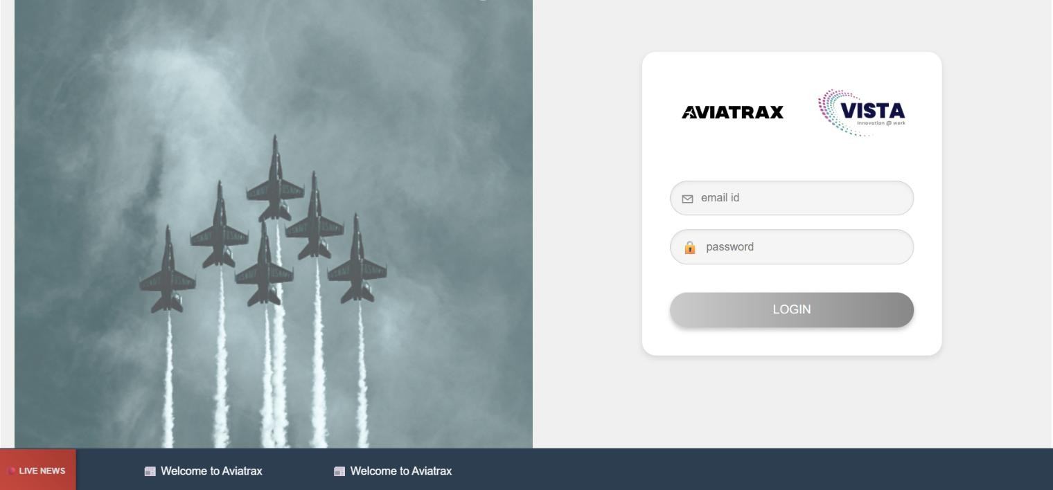

Screen 3.1 -Login
Screen 3.1 displays the login interface of Aviatrax, allowing users to securely authenticate and access the system.

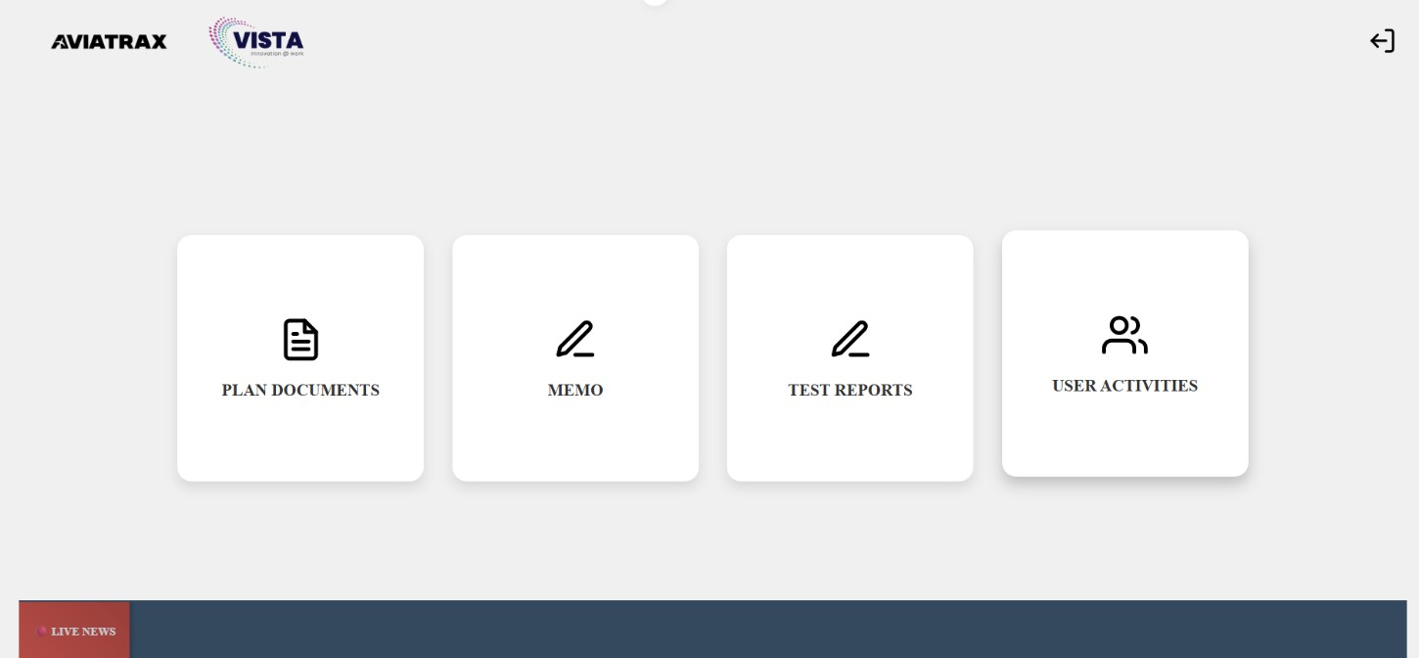
Screen 3.2 -Dashboard

Screen 3.2 Dashboard featuring quick access to Plan Documents, Memo, Test Reports, and User Activities, with live news updates at the bottom.

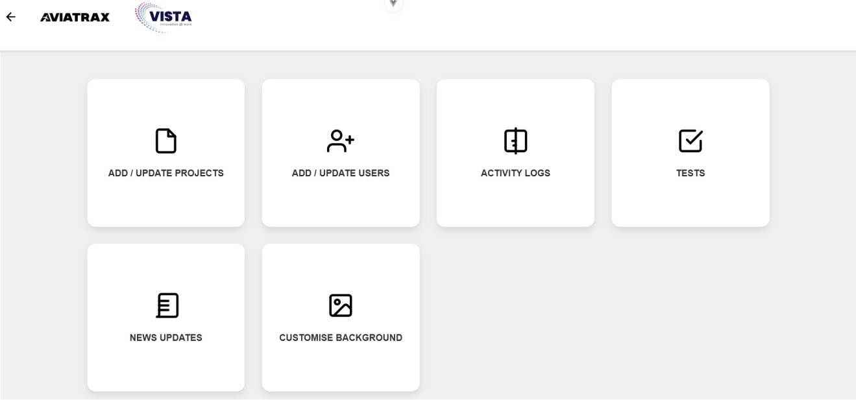

Screen 3.3 -Admin Activities
Screen 3.3, Admin Dashboard with options to manage projects, users, activity logs, tests, news updates, and background customization.

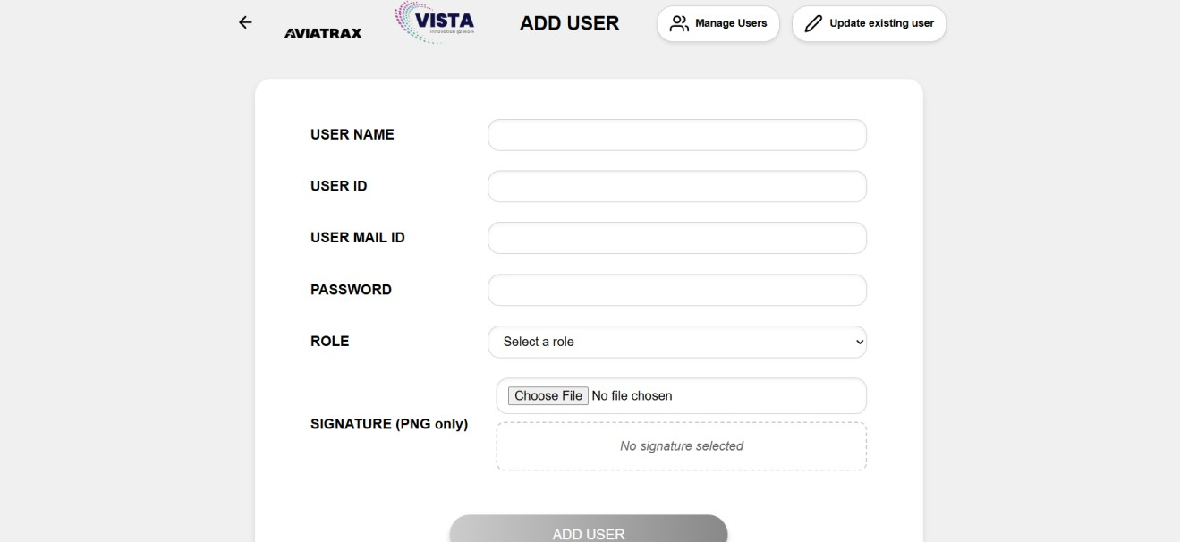

Screen 3.4 – Add User

Screen 3.4 Add user or update existing user details

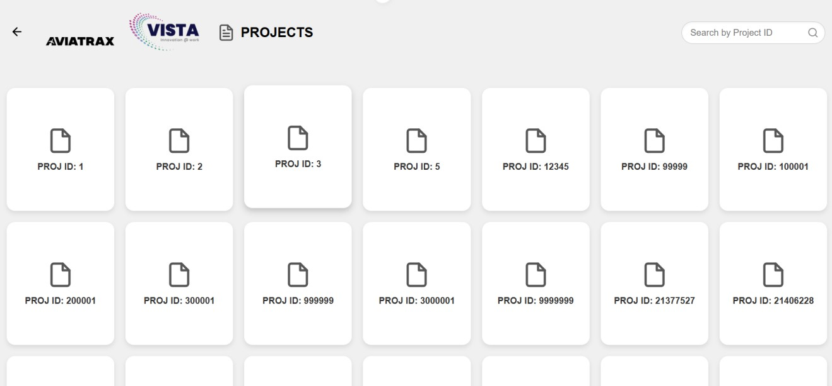

Screen 3.5 – Plan documents

Screen 3.5 Projects Dashboard displaying project cards by ID, with a search option to quickly find projects.

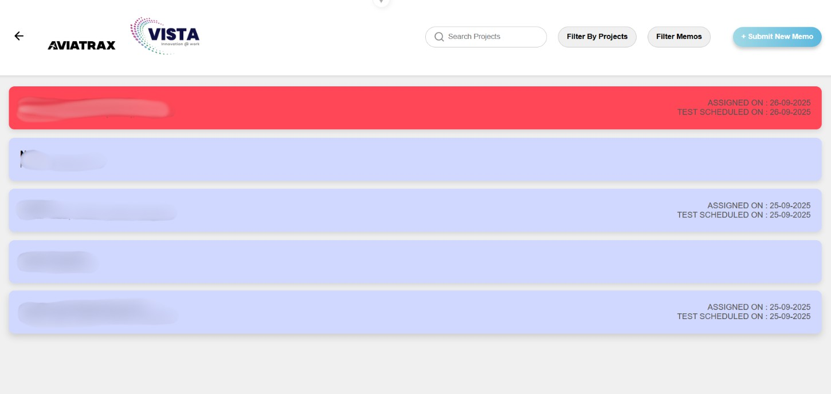

Screen 3.6 – Memo Dashboard
Screen 3.6 Memo Dashboard providing access to manage, and track memos within the system along with memo status.

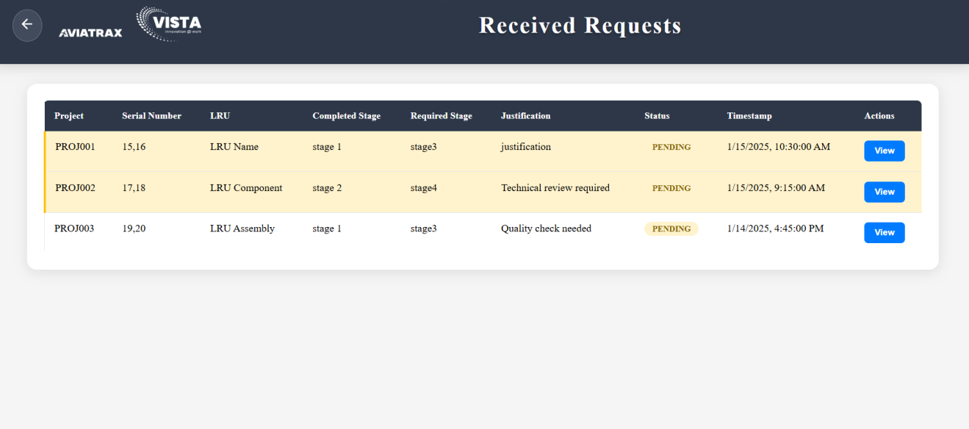
Screen 3.7 – Overriding requests
Screen 3.7, the Overriding Requests feature allows users to request for change in the order of tests to be conducted.

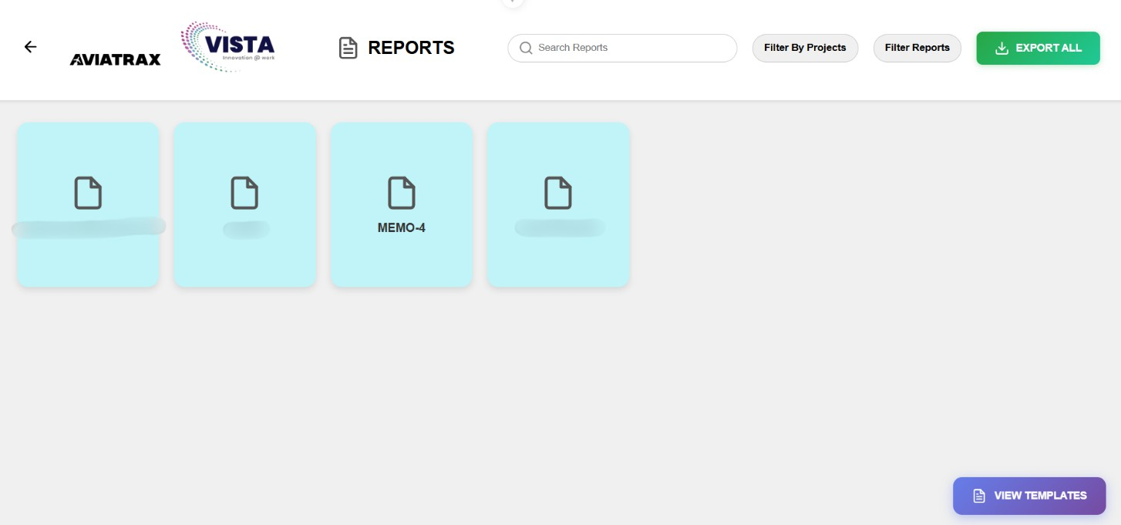
Screen 3.8 -Reports Dashboard

Moving to Screen 3.8, Cards for reports of the respective memos are generated after the approval of memos.

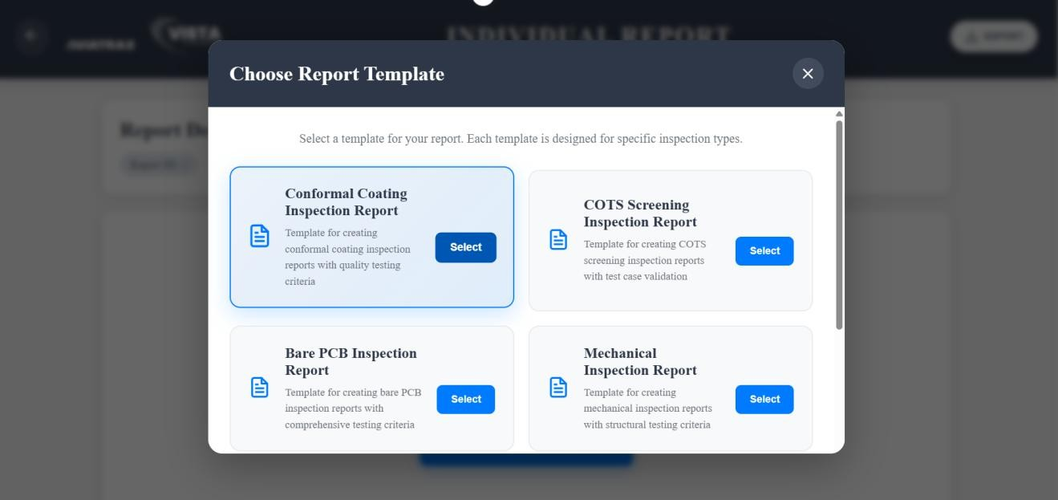

Screen 3.9 – Choose Report Templates

Lastly, Screen 3.9 shows the report template allocation feature

DEPLOYMENT DESIGN
Deployment Design refers to the process of planning and structuring how a software system’s components will be distributed across hardware environments. It focuses on ensuring efficient allocation of resources, seamless communication between components, and optimal performance. This design phase outlines the configuration, placement, and interaction of software modules within the network infrastructure.
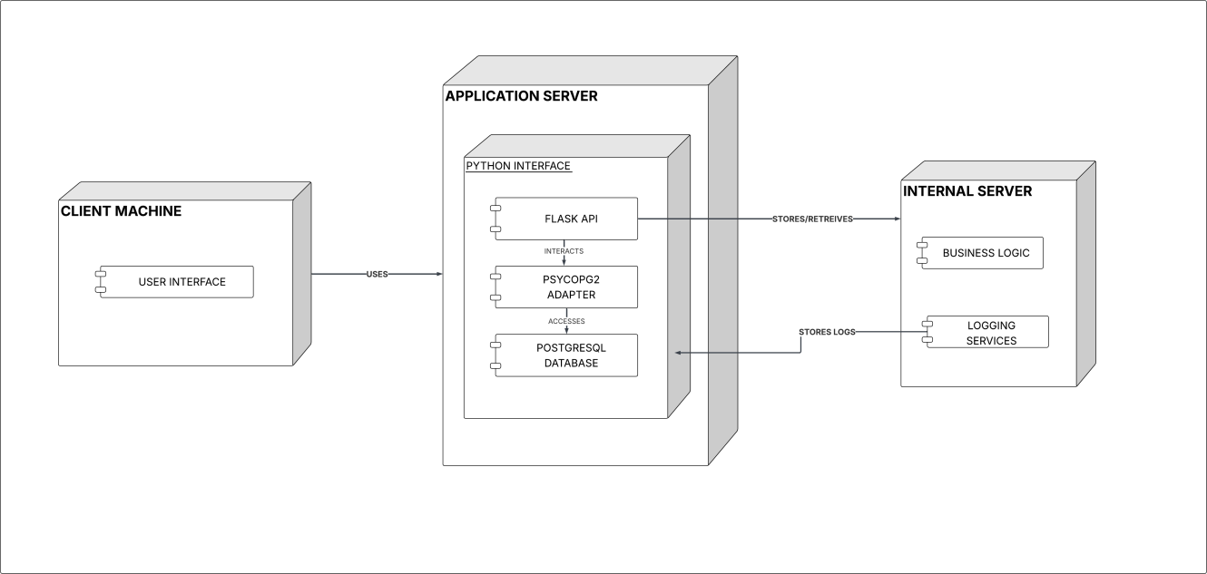

Figure 3.8 Deployment Diagram of Aviatrax

The deployment diagram presented in Figure 3.8 illustrates the deployment architecture of the Aviatrax project, detailing how its key components operate within the system infrastructure. It features distinct nodes representing the user interfaces for various roles, including System Administrators, HR staff, Design Heads, QA Heads, Managers, and Inspectors, highlighting the interaction paths through which these users communicate with the application. Each user role accesses the system through a secure web interface, ensuring role-based access to staff management, document control, QA automation, and reporting functionalities.
At the core of the deployment is the Flask API Server, which handles business logic, inspection workflows, memo processing, and automated report generation. The PostgreSQL database supports centralized storage of user data, documents, memos, inspection records, and report templates, ensuring high reliability and data integrity. Hosting is managed on an internal server to provide secure, controlled access within the organization. The Vue.js front end delivers a

responsive and user-friendly interface, while internal networking ensures seamless communication between the API server, database, and user dashboards. This deployment structure enables efficient system operations, secure data handling, and streamlined QA management across all departments.

NAVIGATION DESIGN

Flow Diagram:
Flow diagrams are used to visually represent the movement of data and the interactions between processes within a business information system. They illustrate how inputs are transformed into stored records, actions, and final outputs such as reports or notifications.
The navigation diagram for Aviatrax outlines the user journey, beginning with the Login Page, where access is granted after secure credential verification. Once authenticated, users are directed to their Role-Based Dashboard, which serves as the primary hub for navigating staff management and QA automation functions. From this dashboard, users can access key modules such as Employee Management (for onboarding and role assignment), Document Management (for uploading and reviewing plan documents), Memos & Override Requests (for raising inspection requisitions or requesting out-of-sequence tests), and Inspection Tracking (to view and update inspection progress). Additional sections include the Templates Dashboard, where the Design Head selects appropriate report formats, and the Report Dashboard, which displays auto-generated and completed inspection reports. Notifications and an activity feed provide real-time updates on tasks, approvals, and inspections, ensuring intuitive access to all core features of the Aviatrax system.

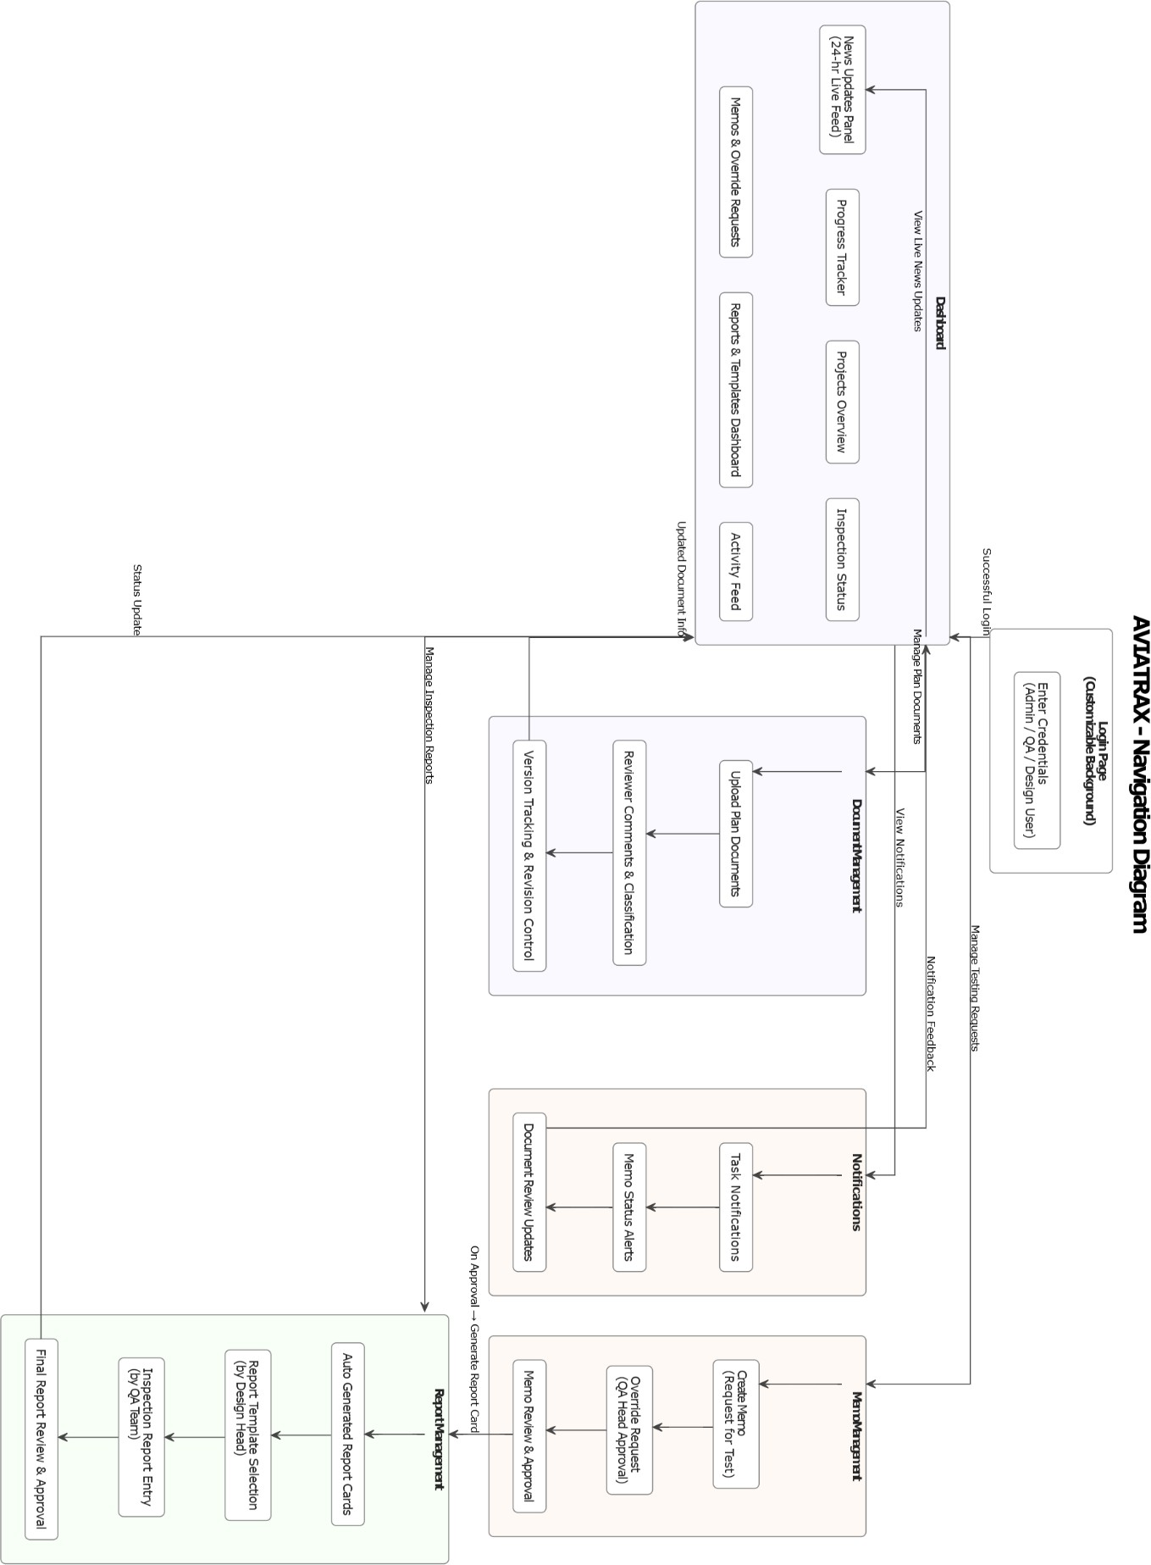

Figure 3.9 Navigation Diagram of Aviatrax

CHAPTER IV

SYSTEM TESTING

System testing is a critical phase in the software development lifecycle that validates the complete and integrated Aviatrax platform to ensure it meets all functional and non-functional requirements. This testing stage evaluates the end-to-end operation of staff management, QA automation, and reporting features, covering aspects such as functionality, performance, security, and usability. By exercising all modules together, system testing verifies that workflows from employee onboarding and document management to memos, inspections, and automated report generation operate reliably and consistently.
For Aviatrax, system testing was carried out across both backend and frontend layers. The backend services, built with Flask and PostgreSQL, were tested using Pytest, generating a detailed report confirming successful execution of API endpoints, database interactions, and business logic. Frontend components, developed in Vue.js, were validated using Vitest, producing a comprehensive test summary of UI elements, component states, and user interaction flows. These combined tests ensured that core processes such as user and Role-based access control, project creation, user flows, database connection and memo flows performed correctly under varied scenarios. By rigorously testing both layers, Aviatrax achieves a stable, secure, and dependable environment ready for deployment.

4.1 TEST CASES AND REPORTS
Test cases and reports validate Aviatrax’s key functions, including staff management, document control, memos, inspections, and automated report generation. Backend tests using Pytest and frontend tests with Vitest define inputs, conditions, and expected outcomes, providing clear pass/fail results to ensure system accuracy and stability.

Table 4.1 List of Test case Scenarios

TEST CASE ID | TEST CASE SCENARIO | TEST STEPS | EXPECTED OUTCOME | RESULT
TC 01 | Login with Valid Credentials | - Enter valid username and password  - Click Login | User is successfully authenticated and redirected to their role-based dashboard. | PASS
TC 02 | Login with Invalid Credentials | - Enter invalid username or password 2. Click Login | Login is rejected and an error message is displayed. | PASS
TC 03 | Dashboard Data Display | - Login 2. Navigate to dashboard | Dashboard loads with key metrics, memos, inspection status, and notifications displayed correctly. | PASS
TC 04 | Employee Onboarding | - HR adds new employee details and submits | Employee record is saved, and credentials are generated for system access. | PASS
TC 05 | Document Upload and Version Control | - Design team uploads a new document with metadata | Document is stored with correct version number and is visible for QA review. | PASS
TC 06 | Document Review and Approval | - QA reviewer opens uploaded document 2. Adds comments and approves/rejects | Document status updates to Approved/Rejected/Revision Required with reviewer comments recorded. | PASS
TC 07 | Memo Submission | - Design team submits memo requesting inspection | Memo is logged and visible to QA Head for review. | PASS
TC 08 | Override Request | - Submit override request to change test sequence | QA Head receives request and can approve or reject. | PASS

TEST CASE ID | TEST CASE SCENARIO | TEST STEPS | EXPECTED OUTCOME | RESULT
TC 09 | Auto-Generate Report Card | 1. QA Head approves memo | Empty report card is created in the Report Dashboard linked to the approved  memo. | PASS
TC 10 | Template Selection for Report | 1. Design Head selects a report template from Templates Dashboard | Selected template is applied to the auto-generated report card. | PASS
TC 11 | Task Assignment for Inspection | - QA Head assigns inspection task to a QA team member | Task is saved, and the assigned inspector receives a notification. | PASS
TC 12 | Inspection Execution & Status Update | - Inspector performs test  - Enters observations and results | Inspection status updates to Pass/Fail/Pass with Observations and logs are  stored in database. | PASS
TC 13 | Automated Report Generation | - Complete inspection and trigger report generation | Final report is compiled using selected template and stored in the report archive. | PASS
TC 14 | Notifications | - Trigger events (memo approval, task assignment, report completion) | Users receive real-time dashboard and email notifications. | PASS
TC 15 | Audit Log Verification | - Perform actions like uploads, approvals, and task updates | All actions are recorded accurately in the audit trail for compliance review. | PASS
TC 16 | Performance Testing | - Upload large documents and run multiple inspection tasks simultaneously | System maintains stable performance with acceptable response times. | PASS

CHAPTER V

SYSTEM IMPLEMENTATION

Implementation is the process of converting a new or a revised system design into an operational one. It is the most crucial stage in achieving a new successful system and in giving confidence to the new system for the teams that it will work efficiently and effectively. In this phase, one can build the components either from scratch or by composition. Given the architecture document from the design phase and requirement document from the analysis phase, one can build exactly what has been requested.

IMPLEMENTATION PROCEDURE

Backend Services with Flask
      - Built the core backend using Flask to manage workflows for staff management, document handling, memos, inspections, and report generation.
      - Configured PostgreSQL as the central database for user records, documents, inspection data, and audit logs.
      - Developed APIs to enforce role-based access, manage task assignments, and apply automated logic for inspection outcomes.

Document Management with Comments and Version Tracking
      - Implemented document upload with structured metadata and reviewer comments to facilitate QA feedback.
      - Integrated automatic version tracking, where a new version is generated when revisions are submitted in response to reviewer comments.
      - Maintained full traceability of changes across document lifecycles.

Memo and Report Workflow Automation
      - Enabled creation of memos for inspection requests and override approvals in out-of- sequence test scenarios.
      - Configured the system to automatically generate an empty report card upon memo approval.
      - Linked report templates to test types, enabling the Design Head to apply the appropriate
template for final report preparation.

Inspection and Task Management
      - Developed modules for QA Heads to assign inspection tasks and monitor real-time progress.
      - Implemented logic to classify results as Pass, Fail, or Pass with Observations.
      - Configured notifications to alert stakeholders of approvals, assignments, and completed inspections.

Frontend Development with Vue.js
      - Designed responsive, role-specific dashboards for HR, QA, and Design teams.
      - Added modules for document uploads with comments, memos, inspections, and report templates with live tracking.
      - Integrated activity feeds and notification panels to ensure transparency and efficient communication.

System Testing and Deployment
      - Conducted backend testing with Pytest for APIs and business logic, and frontend testing with Vitest for UI validation.
      - Performed load and usability testing to ensure stable performance under multiple concurrent users.
      - Deployed the system on a secure internal server, maintaining confidentiality, role-based security, and controlled access.

CHAPTER VI CONCLUSION
The Aviatrax project has successfully implemented a comprehensive system for staff management and QA automation, enabling structured document handling, memo-based inspection requisitions, and automated report generation. The system streamlines workflows through role-based dashboards, inspection task assignments, and real-time notifications, ensuring clarity and accountability across teams. By incorporating reviewer comments with version tracking, memo overrides, and template-driven reporting, Aviatrax meets its core objectives of improving transparency, accuracy, and process efficiency. With its intuitive frontend and reliable backend processes, the platform provides a robust and secure environment for managing quality assurance activities and staff operations.

FUTURE ENHANCEMENTS

    - AI-driven Report Evaluation: Incorporating local machine learning models to analyze inspection data and automatically suggest outcomes, reducing dependency on manual evaluation.
    - Dynamic Workflow Management: Supporting adaptive inspection workflows that adjust test sequences based on project needs, minimizing the need for manual override requests.
    - Configurable Dashboards: Allowing role-based users to customize dashboards with widgets for memos, inspections, reports, and staff activity tracking.
    - Automated Compliance Validation: Introducing offline modules to check reports and documents against predefined industry and organizational standards.
    - Enhanced Notifications: Improving the notification system with priority-based alerts and local escalation mechanisms to keep stakeholders informed even without external integrations.

BIBLIOGRAPHY

- Sommerville, Ian. Software Engineering. Pearson, 10th Edition, 2016.
- Fowler, Martin. Patterns of Enterprise Application Architecture. Addison- Wesley, 2002.
- Pressman, Roger S. Software Engineering: A Practitioner’s Approach. McGraw-Hill, 8th Edition, 2015.

WEB REFERENCE

- https://vuejs.org/ - Frontend
- https://vuetifyjs.com/ - CSS styles
- https://flask.palletsprojects.com/- Backend
- https://www.postgresql.org/ -Database

